BUILDING RESILIENCE (emotional & mental strength)
Session 5. A Future thinking mindset to flourish
Whether professional or personal, the principles are the SAME!
Notes: “Wow” moments (make a note of the things which make you “click”…ie “wow moments” eg. key ideas, thoughts or statements – you can then refer to them in future)

I’d like you to write down the things that YOU bring to the table.

I’d now like you to note down what’s missing (eg: for my work I am not an accountant, although I can keep my books)

Then I’d like you to note down from whom you can source what you need

ADDITIONAL: What are your needs and WHO meets those specific ones?

Love Languages
Try the test www.5lovalanguages.com
How do you compare with those in your “team” (work or play!)
ME
Gifts
Acts of service
Intimacy
Time
Words of affirmation

What’s my headline this year?

What is your newspaper headline?

Identify the key task to achieve

Identify 3 steps that you need to begin

How will I push into my ZONE OF EXCELLENCE DAILY?

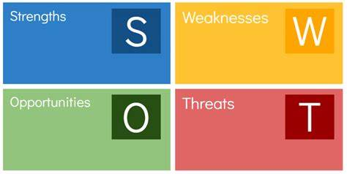

www.draudreyt.com
YouTube: Dr Audrey Tang https://www.youtube.com/channel/UCnn8-Waxrg6TmuNPHL1NQmg?view_as=subscriber
@draudreyt

