www.draudreyt.com

One route to wellbeing is learning to BE well
with Dr Audrey Tang

Key takeaways
- Recognise and manage low-level stress
- Reduce the negative effects of overthinking
- Ride out change and uncertainty
- Respect and revive your inner strength...the skills we gain may leave us over time, who we are at the core is what really counts.

Start building resilience with practical, easily applicable methods to strengthen your mental and emotional health...just like you would physical health!

Building resilience means building 2 key things:
- The ability to minimise the effect of stress OR to be able to reverse it faster
AND
- Channelling the headspace and energy (now no longer held hostage by stress) into the opportunity to thrive.

Doing a alone will help you move from Not OK to OK
Doing b as well will set down the conditions for you to flourish

…and the best time to do it is OUTSIDE the point of adversity – although for many in highly stressful jobs, this is not always possible…so I’d say, start when you feel able to!!

WE BECOME WHAT WE PRACTICE

It is not the big choices in life that make the greatest impact, but the little ones we choose to make every single day – such as, do I do that run, or scroll through social media

We get very good at what we practice…if we are often distracted, is that because we have worked at that more than focus?

It is time to know what you want, and recognise that you have the tools to achieve it, BUT only if you choose to use them

PART 1: Optional tips to reduce cortisol production (resilience to manage stress)
The gratitude stretch
Stretch your arms and think of someone you’re grateful to have in your life
Stretch your legs and think of something you’re grateful to have in your life
Shake out and think about one thing you are looking forward to today.

Do one thing to make someone else smile
While engaging in things that WE enjoy definitely raises our positivity, research shows that even just seeing the act of kindness towards others makes us feel even better. It doesn’t have to be expensive – just dropping a text, or sharing something funny – even stroking your pet can make them feel good – and you’ll feel great too!

Speak kindly to yourself
When you plant a seed, you don’t say things like “I’ll give you 10 minutes and you’d better grow”, so although you might want something, treat that desire like a seed – plant it, do all the things to nurture it, and be patient. (…and don’t forget, sometimes, you might grow more
than you thought!!)
CHALLENGE: For every -ve statement you catch yourself saying about yourself or someone else – give 2 positives (and if you struggle, one solution is to not offer the negative in the first place!)

Don’t sweat the small stuff
Yes, there’s a big decision to be made if you’re going to buy one house over another, BUT if you’re trying to decide between having Indian or Chinese takeout tonight and both places are great, why waste time on the choice…ask yourself instead – if (select one) were the only choice, would I be happy with that? And then go spend your time and energy on something more important!!

PART 2: Reduce the impact of stress in the moment
54321 (getting you grounded outside your head)
5 things you can see
4 things you can hear
3 things you can touch
2 things you can smell
1 think you can taste

STOP Technique for negative thinking
Stop: Reflect on what thoughts of insecurity drive you to do. Eg: get into a funk, throw
a pity party in your head, look for other jobs
Take a step back Explore some of the consequences of the actions you have taken
and decide whether they serve you or not
Observe other options: Ask yourself: How might I behave if I didn’t have that thought
Proceed: From those behaviours – proceed with a different response (anything at all)
next time you recognise those thoughts

TIPP Technique
Temperature
Intensity
Paired muscle relaxation
Paced breathing

A “Zentangle”

A “CALM KIT”
Items eg: textures, temperatures, fiddle toys
Affirmations: eg. Even if I can’t control anything else, I can control my breathing
Useful numbers: eg. Best friend/GP/Mentor
Things to do that make you smile: eg. Books, images, pictures

CIRCLE OF INFLUENCE (do what you CAN do!)

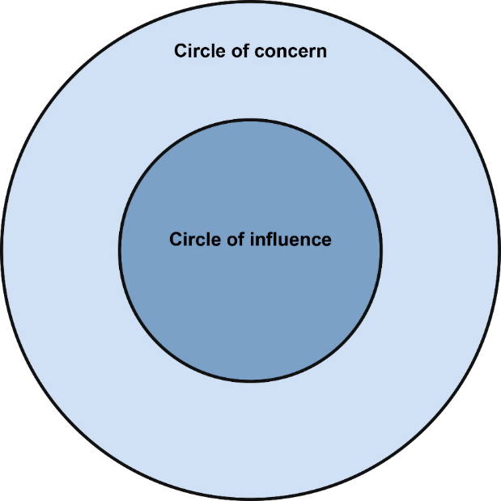

PART 3: Recognise Stress triggers
The body scan
Scan each part of your body working from toes to head recognising how it feels right now AND the difference between tensing and relaxing it

Emotion scan
Think of a time when you were:
Happy – where do you feel the emotion
Sad –
Decisive and confidence –
Angry –
Feeling loved –
Worried –
Excited –

Then use your feedback from your body when it comes to making decisions
PART 4: You’ve survived…now thrive (resilience and growth)
Know your goals
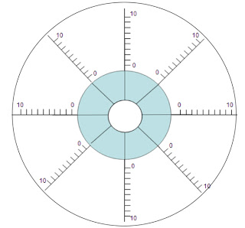

Use this to break down your goal(s) or even projects into manageable pieces AND get a clear visual of the areas that need work and those with which you are on track.

Know how to spend your time (and energy!)

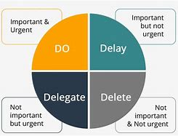

Set boundaries

“no” is a complete sentence, but if you struggle try:
DELAY – I can tell you later
DEFER – I can’t by X can/Here’s one I made earlier
DICTATE – I can only help between x and y
ASK: How would YOU like me to help you!?

Retain a mental social distance!
Maybe there will be some people you want to see, maybe there won’t, but given that Positive psychology research has also found that healthy relationships are key to a happy life, make sure your network is one that brings you joy.
- Identify what YOU really want out of a friendship and actively seek it out (or spend time with those in your life who already give that to you…as a bonus it means you can genuinely say “no” to the more exhausting people without feeling bad…you really ARE already busy!
Look carefully at your current relationships. Ask yourself:
- Which ones are reciprocal?
- Which ones bring me joy?
- Which ones encourage honesty?
- Which ones can I rely on?
and most importantly
- Which ones are with people I respect for their own values and actions? (Which ones does I actively want to choose?)

Then actively choose to spend time with those people (and the others can, quite legitimately be told – “I’m sorry, already booked up!”)

PART 5: Remaining motivated

THE STORYBOARD
- Where am I now?

- Where did I start?

- Highs and Lows

- What keeps/kept me motivated?

- What have I learned?

- Who am I grateful for?

- Where next?

PERSONAL PLEDGE (and book the time off in your calendars)

“ME TIME”: I will set aside ____________________ for me, and in this time I will _______________________________________________________________________

The reason why we book our “development time” into our calendar. Timetable yourself in every day – making that commitment to yourself as important as your commitments to others – and stick to it, whether you are working on your goals, undertaking formal learning, or simply having a cup of tea while it’s hot!

End

Reproduced with permission of Dr Audrey Tang CPsychol

