BUILDING RESILIENCE (emotional & mental strength)
Session 4: The art of BEING well! (Face psychological stress with psychological strength)
Notes: “Wow” moments (make a note of the things which make you “click”…ie “wow moments” eg. key ideas, thoughts or statements – you can then refer to them in future)

Resilience is about navigating 3 dips
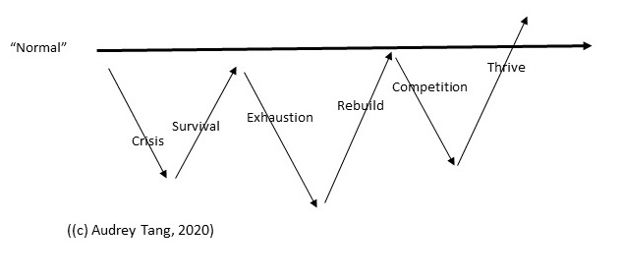
STRESS
Crisis causes the stress response, resistance leads to survival
RESILIENCE FOR GROWTH
BUT the same mental & emotional strength then helps us rebuild while exhausted and thrive through competition

KNOW YOUR GOAL
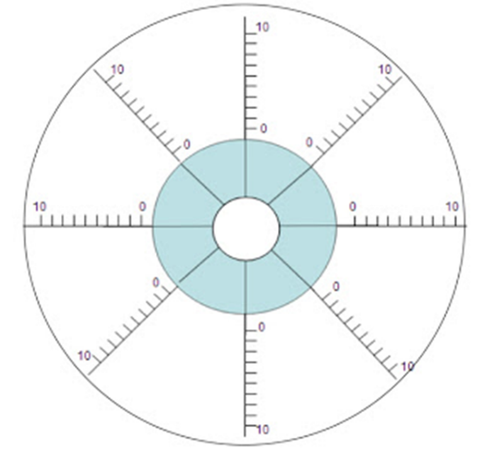

USE THE URGENT IMPORTANT QUADRANT
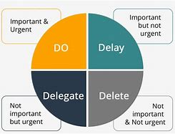

Focus with a vision board
- Personal development/Health
- Career
- Financial
- Inspirations
- VALUES
- Personal development/Health
- Career
- Financial
- Inspirations
- VALUES

Who do you invite to tea?

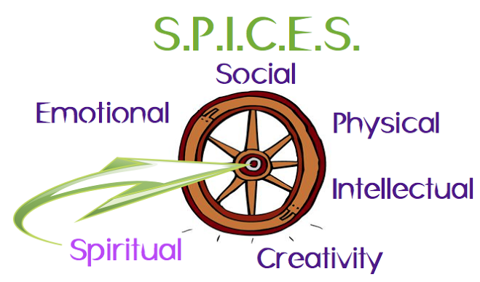

ENERGIZERS | RELAXERS
When you catch yourself enjoying something – ask yourself: Does this Energise or Relax me – and note it down

Now you have a checklist of things that you can do when you need to

SECRET TIP: Look out for any behaviours that fall within:
“PERMA” – 5 pillars of wellbeing – as they will OFTEN make you feel good!!

IDEAL ME exercise
- What 3 behaviours does the ideal me do?

- Who does the ideal me “hang out” with? (e.g. the values of those people)

- How does the ideal me talk to myself/others?

- How does the ideal me think?

- How does the ideal me behave?

Then reflect each day:
- How did I do?

- Where did I stumble and why?

- WHO did I react to and where was it?

- What could I do next time?

REMEMBER – what you practice becomes habit

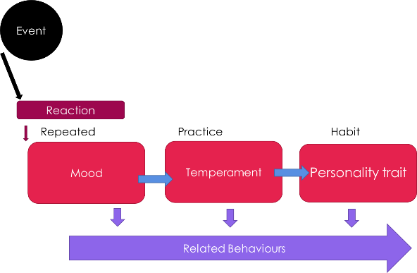

What works for me (PERMA):
(YOU MAY WISH TO UPDATE THIS EACH WEEK AS WE COVER MORE EXERCISES)
What I tried | POSITIVE EMOTION | ENGAGEMENT | RELATIONSHIPS | MEANING | ACHIEVEMENT
Week 1

Week 2

Week 3

Week 4

www.draudreyt.com
audrey@clickproductions.co.uk
@draudreyt (twitter/fb/IG)

